**เรื่อง**

**กลุ่ม กินตลอด**

**สมาชิกในกลุ่ม**

**นางสาวรัชดาพร ทีฆะสุข 64010912511**

**นางสาวอุบลวรรณ วิเศษรัตน์ 64010912518**

**นางสาวพัศพร ปัญชาเมฆ 64010912560**

**นางสาวภัทรวรินทร์ พิมพ์ประชา 64010912562**

**วิชา 0904201 การเขียนโปรแกรมทางธุรกิจ 1**

**ครูผู้สอน อาจารย์ ณัฐอาภา สัจวาที**

**มหาวิทยาลัยมหาสสารคาม**

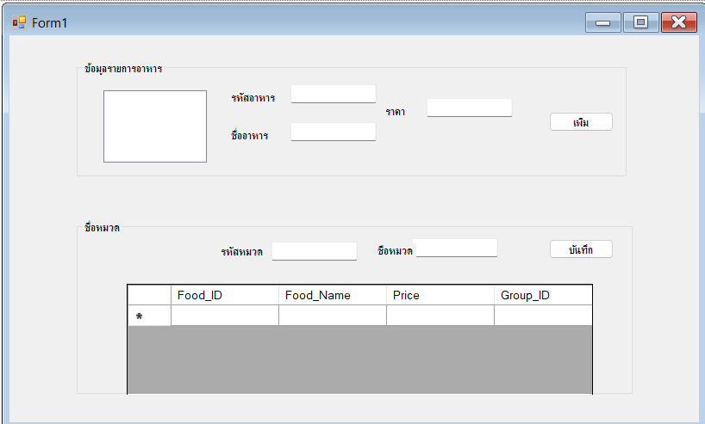

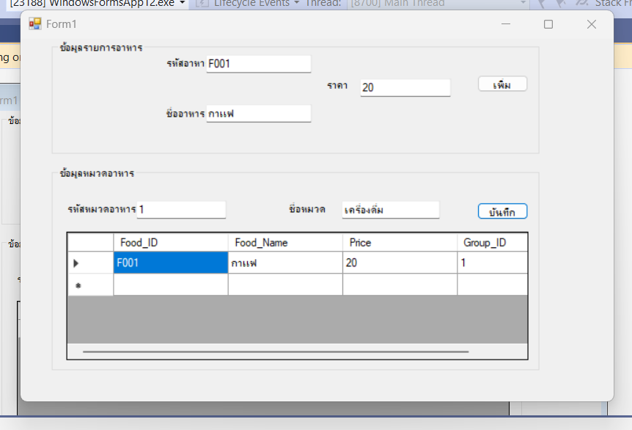

**Form 1**

using System;

using System.Data;

using System.Data.OleDb;

using System.Windows.Forms;

namespace @new

{

public partial class Form1 : Form

{

public Form1()

{

InitializeComponent();

}

private OleDbConnection conn;

private string SQL;

private OleDbCommand comm;

private OleDbDataAdapter da;

private DataSet ds;

private BindingSource bs;

private void Form1_Load(object sender, EventArgs e)

{

string conStr = "Provider=Microsoft.ACE.OLEDB.12.0;Data Source=C: UsersMSI DRAGONOneDriveเอกสารlist1.accd ";

conn = new OleDbConnection();

conn.ConnectionString = conStr;

conn.Open();

ShowListBox();

bs = new BindingSource();

bs.DataSource = ds.Tables["Food"];

textBox1.DataBindings.Add("text", bs, "Food_ID");

textBox2.DataBindings.Add("text", bs, "Food_Name");

textBox3.DataBindings.Add("txet", bs, "Price");

listBox1.SelectedIndex = 0;

ShowDataGrid();

}

private void ShowListBox()

{

SQL = "select * from Food";

comm = new OleDbCommand(SQL, conn);

da = new OleDbDataAdapter();

da.SelectCommand = comm;

da.Fill(ds, "Food");

listBox1.DataSource = ds.Tables["Food"];

listBox1.DisplayMember = "Food_Name";

}

private void ShowDataGrid()

{

SQL = ("select * from Food where Food_ID ='" + textBox1.Text + "'");

comm = new OleDbCommand(SQL, conn);

da = new OleDbDataAdapter();

da.SelectCommand = comm;

ds = new DataSet();

da.Fill(ds, "Food");

}

private void listBox_SelectedIndexChanged(object sender, EventArgs e)

{

if (bs == null)

{

return;

}

bs.Position = listBox1.SelectedIndex;

ShowDataGrid();

}

private void button1_Click(object sender, EventArgs e)

{

SQL = "select * from Food where Food_ID =@FoodID";

comm = new OleDbCommand(SQL, conn);

comm.Parameters.AddWithValue("FoodID", textBox1.Text);

OleDbDataReader dr = comm.ExecuteReader();

if (dr.Read())

{

dr.Close();

SQL = "insert into Patient(Food_ID,Food_Name,Price)";

SQL += "values (@FoodID,@FoodName,@Price)";

comm = new OleDbCommand(SQL, conn);

comm.Parameters.AddWithValue("PatID", textBox1.Text);

comm.Parameters.AddWithValue("PatName", textBox2.Text);

comm.Parameters.AddWithValue("Addr", textBox3.Text);

comm = new OleDbCommand(SQL, conn);

int numRec = comm.ExecuteNonQuery();

if (numRec > 0)

{

MessageBox.Show("เพิ่มข้อมูลเรียบร้อยแล้ว");

}

else

{

MessageBox.Show("ไม่สามารถเพิ่มข้อมูลได้");

}

ShowListBox();

}

}

private void button2_Click(object sender, EventArgs e)

{

SQL = "intert into Treatment(Group_ID,Group_Name)";

SQL += "value (@GroupID,@GroupName)";

comm = new OleDbCommand(SQL, conn);

comm.Parameters.AddWithValue("GroupID", textBox4.Text);

comm.Parameters.AddWithValue("GroupName", textBox5.Text);

int numRec = comm.ExecuteNonQuery();

if (numRec > 0)

{

MessageBox.Show("บันทึกข้อมูลเรียบร้อยแล้ว");

}

else

{

MessageBox.Show("ไม่สามารถบันทึกข้อมูลได้");

}

}

private void dataGridView1_CellContentClick(object sender, DataGridViewCellEventArgs e)

{

if (e.RowIndex == -1)

{

return;

}

textBox4.Text = dataGridView1.Rows[e.RowIndex].Cells[0].Value.ToString();

listBox1.SelectedItem = dataGridView1.Rows[e.RowIndex].Cells[1].Value.ToString();

textBox5.Text = dataGridView1.Rows[e.RowIndex].Cells[2].Value.ToString();

}

}

}